**Riphah International University, GGC, Islamabad**



**DataBase BSSE-4**

**Submitted to: Miss Hafsah Mahmood**

**LAB 5**

|  |  |  |
| --- | --- | --- |
| **NAME** | **SAP ID** | **Email ID** |
| Valeeja Jamil | 49100 | 49100@students.riphah.edu.pk |

**Task 1:**

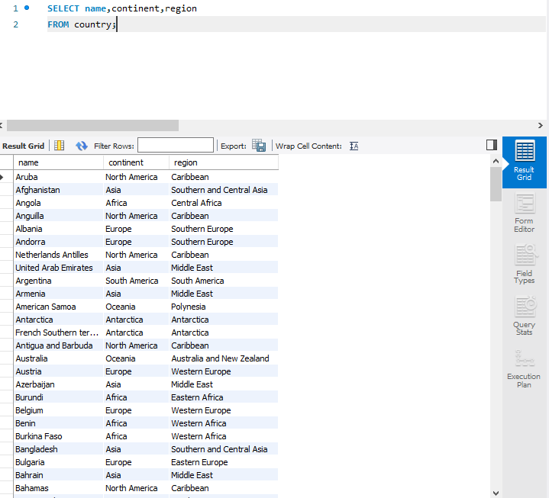

**Task 2:**

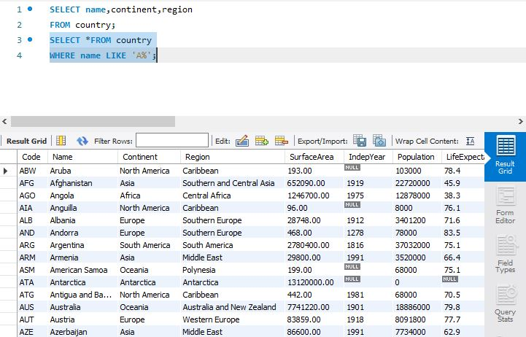

**Task 4:**

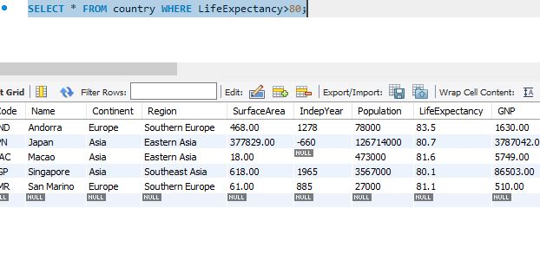

**Task 5:**

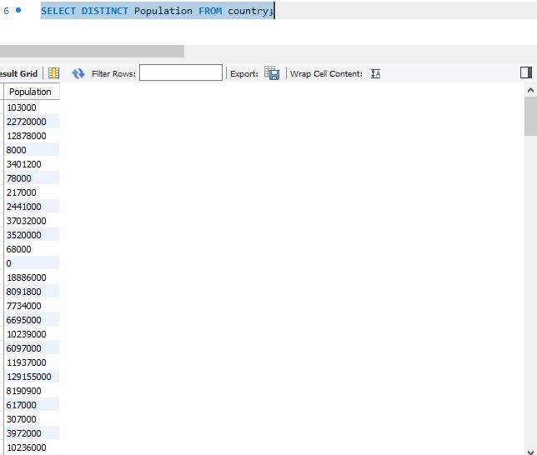

**Task 6:**

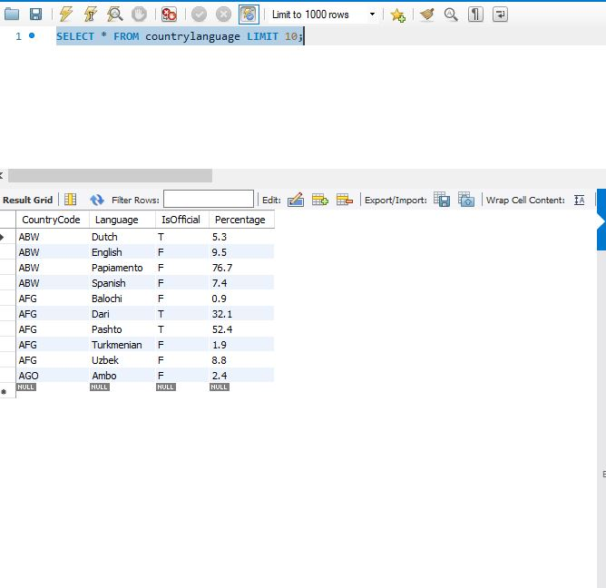

**Task 9:**

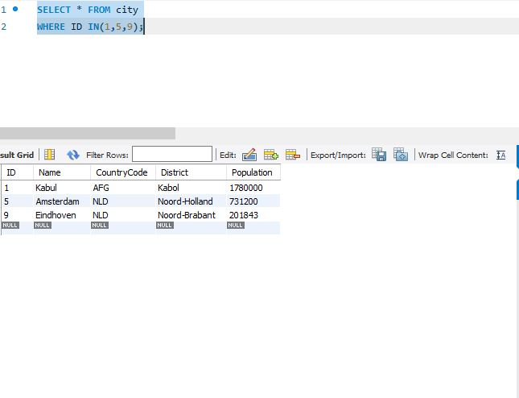

**Task 10:**

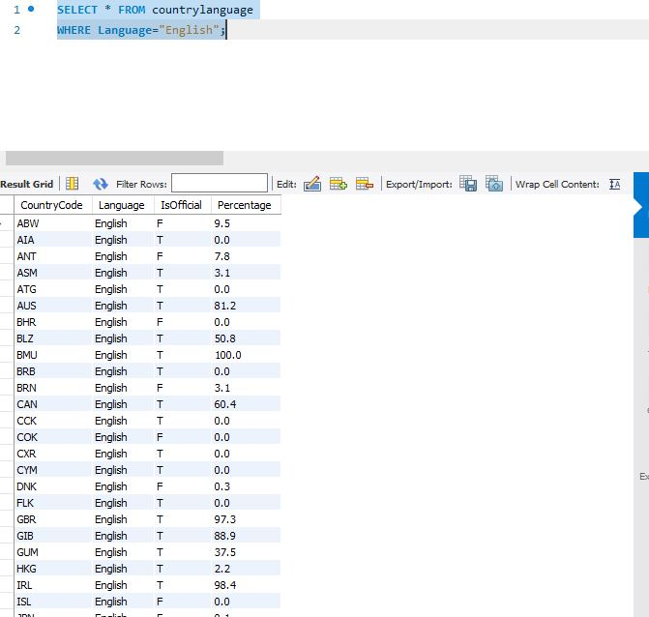

**Task 3:**

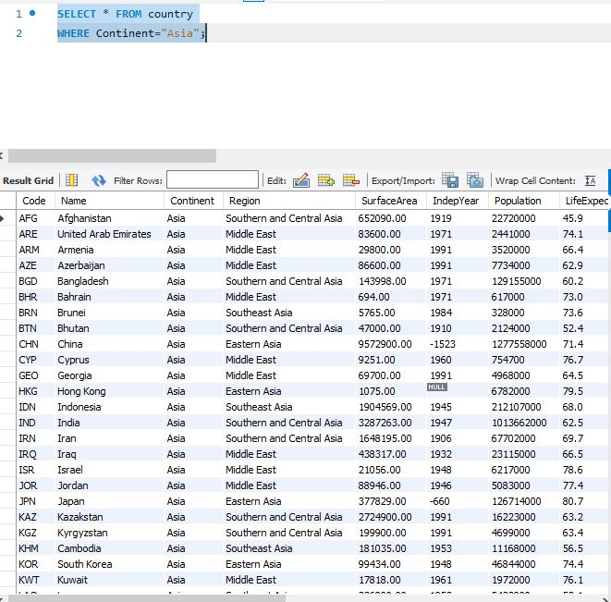

**Task 8:**

